

Practices for Secure Software Report

Table of Contents
Document Revision History 3
Client 3
Instructions 3
Developer 4
1. Algorithm Cipher 4
2. Certificate Generation 4
3. Deploy Cipher 4
4. Secure Communications 4
5. Secondary Testing 4
6. Functional Testing 4
7. Summary 4
8. Industry Standard Best Practices 4

Document Revision History

Version | Date | Author | Comments
1.0 | 10/18/2025 | Cheyenne Anderson

Client



Instructions

Submit this completed practices for secure software report. Replace the bracketed text with the relevant information. You must document your process for writing secure communications and refactoring code that complies with software security testing protocols.

- Respond to the steps outlined below and include your findings.
- Respond using your own words. You may also choose to include images or supporting materials. If you include them, make certain to insert them in all the relevant locations in the document.
- Refer to the Project Two Guidelines and Rubric for more detailed instructions about each section of the template.

Developer
Cheyenne Anderson

Algorithm Cipher

Artemis Financial is a company who wants to expand their clients worldwide, while dealing with sensitive client financial information. They require a checksum for verification. I recommend a SHA-236 for the hash algorithm and AES-256 with TLS/SSL for the overall encryption. The hash function and its bit levels are random, the input value is compressed before being used, the hash value is the name of the data that was compressed, the length is determined by the bit levels. A 256 bit hash has 2^256 possible outputs. A hacker would have to perform 2^128 computations to hack. The process is one way as you can not take a hash value and reconstruct the original data. Data verification includes the sender computing the hash of the data before sending, the recipient then computers the hash received and compares it to the one provided by the sender, if they match the data has not been altered.

Symmetric key algorithms use the same secret key for encryption and decryption.

Non-symmetric uses a pair of keys a public key for encryption and private for decryption.

History of decryption:

Cryptology dates back to ancient times with techniques like the Caesar Cipher. Modern cryptology includes development of mechanical and electric machines and computers.

Milestones:

1977: Publication of Data Encryption Standard, the first standardized block cipher.

Introduction of RSA, the first public asymmetric key.

1993: Publication of SHA-O hash function

1995: SHA-1

2001: AES Advanced Encryption Standard replaces DES

Introduction of SHA-2 to address limitations in SHA-1

Today: Symmetric encryption AES-256 is the standard for general data

RSA- standards for key exchange and digital signatures

Hashing- SHA-256 and SHA-512 standards

Certificate Generation
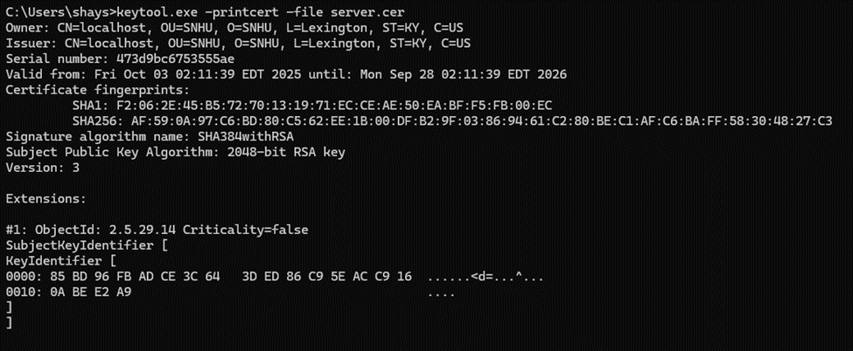

Deploy Cipher

Secure Communications
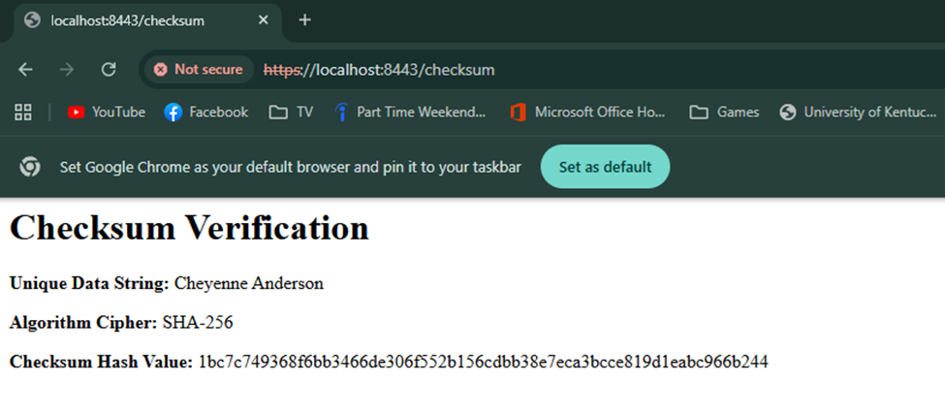

Secondary Testing

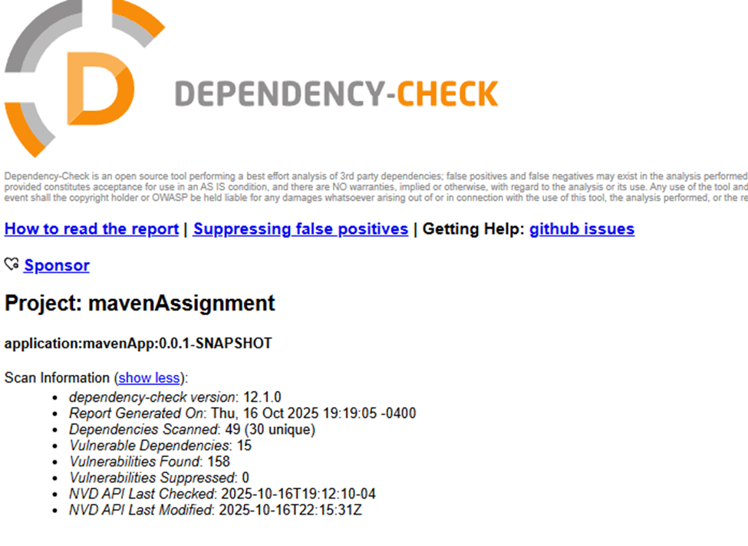
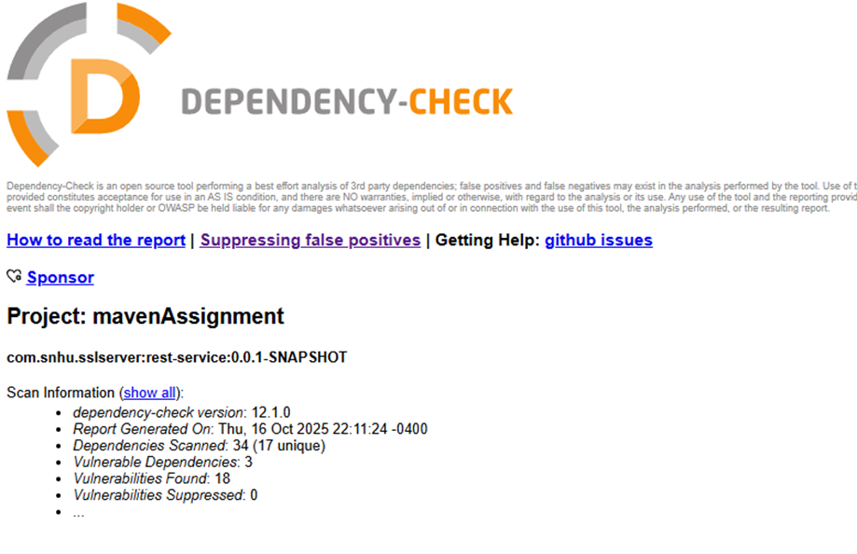
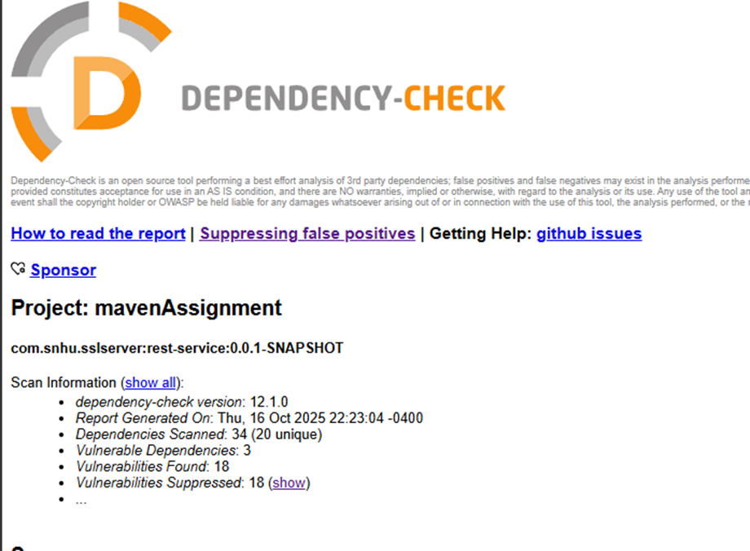

Functional Testing

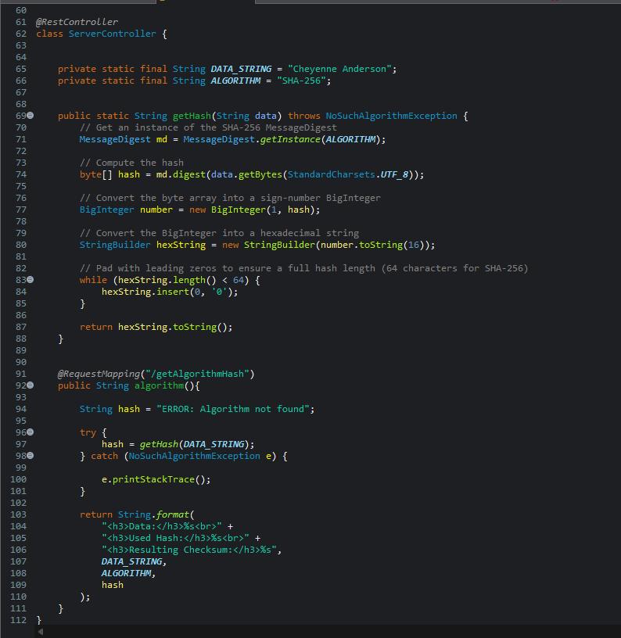
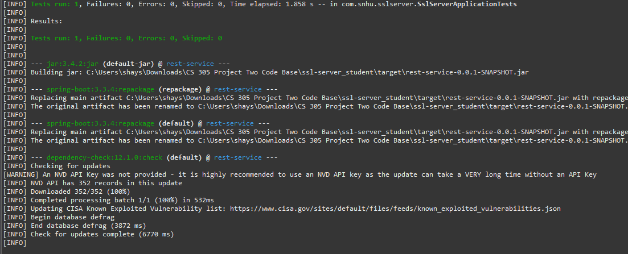

Summary

During the refactor of the code I added a RestController to the code in the SSLServerApplication.java file to be the controller for the hash. The ServerController class addresses the security concern in the diagram. I chose to use the SHA-256 hashing cipher, and upgrade Maven Dependency Check to the newest version 12.1.0. As well as add a suppression file to suppress the files shown in the dependency check seen above.

Industry Standard Best Practices

To counteract security issues, I used industry-standard best practices for coding securely.

- Input validation: validates and sanitizes input to prevent SQL injection.
- Authentication and Passwords: ensures users and applications have strong passwords and hashing algorithms.
- Access: ensuring that users and applications have the minimal permissions needed. Reducing unauthorized access.
- Data storage: Encrypt sensitive data using protocols like HTTPS
- Regular updates: regular security updates to keep dependencies up to date
- Error handling: prevents leak of sensitive information and detects potential attacks.
Applying these industry standards for best practice adds an essential component to a business who needs to protect financial information and gain the trust of customers.

National Institute of Standards and Technology. (2001). Advanced Encryption Standard (AES) (Federal Information Processing Standards Publication 197). U.S. Department of Commerce. https://doi.org/10.6028/NIST.FIPS.197

National Institute of Standards and Technology. (2015). Secure Hash Standard (SHS) (Federal Information Processing Standards Publication 180-4). U.S. Department of Commerce. https://doi.org/10.6028/NIST.FIPS.180-4

